CHAPTER ONE

INTRODUCTION

1.1 Background of the Study
The rapid advancement of information and communication technology has transformed the way information is created, stored, managed, and shared across various sectors, including education. Higher institutions generate a large volume of academic materials every year, especially student research projects. These projects contain valuable knowledge and innovative ideas that can serve as reference materials for future students, researchers, and academic staff. However, in many institutions, project reports are still stored in physical formats such as hardbound copies placed in departmental libraries, making access, retrieval, and preservation difficult.
A project repository is a centralized system designed to collect, store, organize, and provide access to academic project documents through digital means. Web-based repositories have become increasingly important because they enable users to access information from any location with internet connectivity. According to Mgonzo and Yonah (2014), digital repositories enhance the visibility, accessibility, and preservation of scholarly materials while supporting effective knowledge sharing among researchers. Similarly, Okon, Eleberi, and Uka (2020) noted that web-based repositories provide efficient and reliable mechanisms for storing and retrieving academic resources, thereby improving research productivity.
Many universities around the world have adopted digital repository systems to manage research outputs and academic publications. These systems provide advanced search capabilities, secure storage, user authentication, and efficient document management. Al Sbou (2009) emphasized that a web-based project documentation repository simplifies the process of storing, searching, and retrieving project documents, making academic resources more accessible to students and researchers.
In Nigerian tertiary institutions, the management of student projects is still largely dependent on manual methods. This often results in difficulties in locating previous projects, duplication of research topics, loss of documents, and limited access to academic resources. To address these challenges, this study proposes the design and implementation of a Student Web-Based Project Repository that will provide a centralized platform for uploading, managing, searching, and retrieving student project reports electronically.

1.2 Research Justification/Motivation
The motivation for this research stems from the increasing need for effective management and preservation of academic project materials within tertiary institutions. Traditional methods of storing project reports in physical libraries are associated with numerous limitations, including restricted accessibility, document deterioration, and inefficient retrieval processes.
Recent studies have shown that web-based repository systems significantly improve access to academic resources and facilitate knowledge sharing among students and researchers. Onwuegbuzie and Adu (2024) observed that centralized digital repositories streamline project management processes and improve the overall quality of academic research by providing easy access to previous project works.
Furthermore, the increasing number of students and project submissions each academic session creates a demand for a scalable and efficient system capable of managing large volumes of project documents. The proposed system is motivated by the need to provide a secure, organized, and user-friendly platform that will preserve institutional knowledge and support future research activities.

1.3 Problem Statement
Despite the importance of student research projects, many higher institutions still rely on manual storage systems that present several challenges. Project reports are often stored in departmental libraries where they are difficult to access, prone to physical damage, and susceptible to loss. Students searching for previous works frequently spend considerable time locating relevant materials, and in some cases, the desired projects may not be available.
Another major challenge is the duplication of project topics and content. Due to the absence of a centralized repository, students may unknowingly select topics that have already been extensively researched. Soyemi and Isinkaye (2017) highlighted that inadequate monitoring of previous projects contributes significantly to project duplication and reduced research originality among students.
Additionally, the manual management of project documents creates administrative burdens for departmental staff and limits the dissemination of valuable research findings. The absence of an efficient digital platform therefore hinders knowledge preservation, collaboration, and academic development.
This study seeks to address these challenges through the development of a Student Web-Based Project Repository that will provide secure storage, easy retrieval, efficient project management, and enhanced accessibility to academic project materials.

1.4 Aim and Objectives of the Study

Aim
The aim of this study is to design and implement a Student Web-Based Project Repository for the efficient storage, management, and retrieval of student academic projects.

Objectives
The specific objectives of the study are to:
- design a centralized web-based repository for student project reports.
- develop a secure user authentication and authorization system.
- implement project upload, storage, and management functionalities.
- develop a search and retrieval mechanism for easy access to project documents.
- reduce duplication of research topics by providing access to previously completed projects.
- enhance the preservation and accessibility of academic research outputs.

1.5 Scope of the Study
This project focuses on the design and implementation of a web-based repository system for managing student project reports within a tertiary institution. The system will provide functionalities such as user registration, login authentication, project upload, project categorization, document storage, search operations, and project retrieval.
The repository will primarily serve students, lecturers, and administrators within the institution. The study is limited to the management of undergraduate project reports and does not cover journal publications, examination records, or other institutional documents.

1.6 Significance of the Study
The development of a Student Web-Based Project Repository will provide numerous benefits to students, lecturers, researchers, and educational institutions.

1.6.1 Sociological Impact
The system will promote knowledge sharing and collaboration among students and researchers by providing easy access to previous academic works. It will encourage innovation and reduce unnecessary duplication of research efforts. Students will be able to learn from existing projects and build upon previous research findings, thereby fostering a culture of academic excellence.

1.6.2 Technological Impact
The project contributes to the digital transformation of academic record management. It demonstrates the practical application of web technologies, database management systems, and information retrieval techniques in solving real-world problems. The repository will improve the efficiency of project storage, retrieval, and management through automation.

1.6.3 Economical Impact
The implementation of a digital repository will reduce the cost associated with printing, physical storage, and maintenance of hardcopy project reports. Institutions can save resources previously allocated to manual record keeping while improving operational efficiency. Additionally, the system minimizes the risk of document loss, thereby preserving valuable research investments.

1.7 Definition of Terms
Repository: A centralized location where digital documents and information are stored, organized, and managed.
Web-Based System: An application that operates through a web browser and is accessible over a network or the internet.
Database: An organized collection of related data stored electronically for easy access and management.
Project Repository: A digital platform designed for storing, managing, and retrieving academic project documents.
Authentication: The process of verifying the identity of a user before granting access to a system.
Administrator: A user responsible for managing the repository system, users, and uploaded content.
Information Retrieval: The process of searching and obtaining relevant information from a database or repository.

1.8 Organization of the Study
This project report is organized into five chapters.
Chapter One presents the introduction, background of the study, motivation, problem statement, aim and objectives, scope, significance, definition of terms, and organization of the study.
Chapter Two reviews relevant literature related to web-based repositories, digital libraries, document management systems, and existing repository solutions.
Chapter Three describes the methodology adopted for the design and development of the proposed system, including system architecture, database design, and implementation tools.
Chapter Four presents the implementation details, system interfaces, testing procedures, results, and discussion of findings.
Chapter Five provides the summary of the study, conclusion, recommendations, and suggestions for future research.

CHAPTER TWO

LITERATURE REVIEW

2.1 Introduction
This chapter reviews relevant literature related to web-based systems, student project repository systems, database management systems, web development technologies, and existing repository solutions. The review provides an understanding of previous studies and identifies gaps that justify the development of the proposed system.

2.2 Concept of Web-Based Systems
A web-based system is an application that operates through a web browser and can be accessed over a network or the Internet. Unlike traditional desktop applications, web-based systems allow users to access information and services from different locations using various devices. According to Pressman and Maxim (2020), web applications provide flexibility, scalability, and ease of maintenance, making them suitable for modern information management systems.
Web-based systems have become widely adopted in educational institutions due to their ability to facilitate communication, information sharing, and data management. Sommerville (2016) noted that web technologies support distributed access to resources, thereby improving operational efficiency and user convenience.

2.3 Student Project Repository Systems
A student project repository system is a digital platform used for storing, organizing, managing, and retrieving academic project documents. These systems serve as centralized databases where completed projects can be uploaded, preserved, and accessed by authorized users.
According to Mgonzo and Yonah (2014), digital repositories improve the visibility and accessibility of academic resources while ensuring long-term preservation of scholarly works. Similarly, Tumulak, Balingit, and Malig-on (2016) stated that project repositories encourage collaboration and knowledge sharing among students and researchers by providing easy access to previous research outputs.
Student project repositories also help reduce duplication of research topics and improve the quality of academic work by enabling students to review existing studies before selecting research topics.

2.4 Database Management Systems for Web Applications
A Database Management System (DBMS) is software used for creating, storing, organizing, and managing data efficiently. Databases play a vital role in web-based applications because they provide structured storage for user information, documents, and system records.
According to Elmasri and Navathe (2017), database systems ensure data consistency, integrity, security, and efficient retrieval of information. Common database systems used in web applications include MySQL, PostgreSQL, Microsoft SQL Server, and MongoDB.
For project repository systems, databases are essential for managing project metadata, user accounts, authentication details, and uploaded documents. The integration of a DBMS improves system reliability and facilitates quick search and retrieval operations.

2.5 Technologies Used in Web Development
Web development involves the use of various technologies for designing and implementing web applications. The front-end of a web application is responsible for the user interface and is commonly developed using HTML, CSS, and JavaScript.
HTML provides the structure of web pages, CSS controls presentation and styling, while JavaScript enables interactive functionalities. Duckett (2014) explained that the combination of these technologies forms the foundation of modern web development.
The back-end handles server-side operations such as authentication, data processing, and database interactions. Popular back-end technologies include PHP, Python, Node.js, and Java. According to Nixon (2021), PHP remains one of the most widely used server-side programming languages for database-driven web applications due to its simplicity and compatibility with MySQL databases.

2.6 Related Works and Existing Systems

2.6.1 Development of a Responsive Web-Based Final-Year Project Repository System (FYPRS) for Nigerian Tertiary Institutions by Onwuegbuzie and Adu (2024)

Approach
The researchers developed a responsive web-based Final-Year Project Repository System (FYPRS) using the Laravel framework. The system provides a centralized platform where students can upload final-year projects while lecturers can review and access submitted works. Key functionalities include project submission, authentication, project evaluation, and a search engine.

Architectural Framework
The architecture consists of a web-based user interface, application server, authentication module, project management module, search engine, and centralized database. Students upload project files through the interface while lecturers and administrators access projects through role-based permissions.

Strengths
(i) Provides centralized storage for academic projects.
(ii) Supports role-based access control.
(iii) Includes project search and retrieval functionalities.

Weaknesses
(i) Limited discussion on security threats and data protection.
(ii) No implementation of plagiarism detection.
(iii) Lacks advanced recommendation and analytics features.

2.6.2 Development and Evaluation of the Institutionally Farmed Research Online Repository and Management System (InFORMs) by Javier et al. (2022)

Approach
The authors developed an online research repository known as InFORMs to manage and preserve institutional research outputs. The system was evaluated using the ISO 25010 software quality model to assess usability, functionality, and reliability.

Architectural Framework
The framework consists of a web application layer, research database, user management module, search engine, and reporting tools. The repository allows authorized users to upload and retrieve research resources.

Strengths
(i) High usability and user acceptance.
(ii) Supports long-term preservation of research outputs.
(iii) Complies with software quality standards.

Weaknesses
(i) Focused primarily on institutional research rather than student projects.
(ii) Limited access control customization.
(iii) Does not include intelligent search recommendations.

2.6.3 Web-Based Research Consortium Database Management System by Salvador et al. (2024)

Approach
The study developed a web-based database system for managing research projects across multiple institutions. The system enables real-time monitoring, storage, retrieval, and reporting of research activities.

Architectural Framework
The architecture comprises a centralized database, web interface, reporting module, analytics dashboard, and user management system. Data are collected from participating institutions and stored in a unified repository.

Strengths
(i) Supports multi-institution collaboration.
(ii) Provides real-time reporting and monitoring.
(iii) Enhances information sharing among researchers.

Weaknesses
(i) Designed mainly for research administration.
(ii) Complex deployment requirements.
(iii) Limited focus on student project repositories.

2.6.4 OpenDOAR-Based Institutional Repository Systems by Pinfield et al. (2020)

Approach
The researchers examined institutional repositories registered within OpenDOAR and evaluated their effectiveness in preserving scholarly outputs and supporting open access initiatives.

Architectural Framework
The repositories consist of digital archive servers, metadata management systems, indexing engines, and web portals that allow users to access stored documents.

Strengths
(i) Promotes open access to academic resources.
(ii) Enhances research visibility.
(iii) Supports long-term digital preservation.

Weaknesses
(i) Primarily designed for publications.
(ii) Limited support for undergraduate projects.
(iii) Requires technical expertise for administration.

2.6.5 DSpace Institutional Repository Framework by Smith et al. (2020)

Approach
The study evaluated the implementation of DSpace as a digital repository platform for managing scholarly documents within universities.

Architectural Framework
The system uses a three-tier architecture consisting of presentation, application, and database layers. Metadata indexing facilitates efficient search and retrieval.

Strengths
(i) Open-source and scalable.
(ii) Strong metadata management capabilities.
(iii) Supports document preservation.

Weaknesses
(i) User interface customization is limited.
(ii) Requires technical configuration.
(iii) Not specifically designed for student project management.

2.6.6 EPrints-Based Digital Repository System by Jones and Andrew (2021)

Approach
The authors investigated the use of EPrints software for managing institutional research repositories and academic documents.

Architectural Framework
The framework integrates document storage, metadata indexing, user authentication, and search functionalities within a web environment.

Strengths
(i) Easy document submission process.
(ii) Supports interoperability standards.
(iii) Efficient indexing and retrieval.

Weaknesses
(i) Limited workflow automation.
(ii) Basic user interface design.
(iii) Minimal support for project supervision processes.

2.6.7 Cloud-Based Academic Repository System by Ahmed et al. (2021)

Approach
The researchers proposed a cloud-based repository system for storing and sharing academic resources using cloud infrastructure.

Architectural Framework
The system combines cloud storage services, web interfaces, authentication mechanisms, and centralized databases.

Strengths
(i) High scalability.
(ii) Reduced infrastructure costs.
(iii) Improved accessibility.

Weaknesses
(i) Dependency on internet connectivity.
(ii) Potential cloud security concerns.
(iii) Limited offline accessibility.

2.6.8 Intelligent Academic Document Retrieval System by Kumar and Singh (2022)

Approach
The study developed an intelligent document retrieval system that uses metadata indexing and keyword matching to improve search performance.

Architectural Framework
The architecture consists of document repositories, indexing engines, search modules, and ranking algorithms.

Strengths
(i) Fast document retrieval.
(ii) Improved search accuracy.
(iii) User-friendly search interface.

Weaknesses
(i) Limited support for multimedia content.
(ii) Requires quality metadata.
(iii) High indexing overhead for large repositories.

2.6.9 Digital Library Repository System Using PHP and MySQL by Hassan et al. (2023)

Approach
The researchers developed a web-based digital library system using PHP and MySQL for storing and retrieving academic materials.

Architectural Framework
The architecture includes a user interface, application layer, database server, and file management system.

Strengths
(i) Simple implementation.
(ii) Low deployment cost.
(iii) Supports document categorization.

Weaknesses
(i) Basic security implementation.
(ii) Limited scalability.
(iii) No plagiarism detection functionality.

2.6.10 Academic Research Repository with Advanced Search Functionality by Lee et al. (2025)

Approach
The study proposed a repository system that integrates advanced search algorithms and metadata analysis to improve document discovery.

Architectural Framework
The system comprises a repository database, indexing engine, recommendation module, and web application interface.

Strengths
(i) Advanced search performance.
(ii) Better user experience.
(iii) Efficient document organization.

Weaknesses
(i) Increased computational requirements.
(ii) More complex implementation.
(iii) Higher maintenance costs.

2.7 Research Gap
Based on the reviewed literature, the following research gaps were identified:
1. Limited Focus on Student Project Management
Most existing repository systems are designed for managing institutional publications, journals, and research outputs rather than specifically addressing the storage and management of undergraduate student projects.
2. Inadequate Search and Retrieval Features
Many existing systems provide basic keyword search functionalities, making it difficult for users to quickly locate relevant projects based on department, year, author, or research area.
3. Weak Access Control and Security Mechanisms
Several reviewed systems lack robust authentication and authorization features, which may expose sensitive academic documents to unauthorized access and modification.
4. Absence of Project Duplication Prevention
Most repository systems do not provide mechanisms for checking existing project topics before submission, thereby increasing the possibility of research topic duplication among students.
5. Limited User-Friendly and Responsive Design
Some existing repository platforms have complex interfaces and are not fully optimized for mobile devices, reducing accessibility and ease of use for students and lecturers.

2.8 Summary of Literature Review
This chapter reviewed literature related to web-based systems, student project repositories, database management systems, web development technologies, and existing repository solutions. The review revealed that digital repositories improve information accessibility, preservation, and academic collaboration. However, limitations such as inadequate security, limited search functionality, and insufficient support for student project management remain evident in existing systems. These gaps justify the development of the proposed Student Web-Based Project Repository.

CHAPTER THREE

METHODOLOGY

3.1 Introduction
This chapter presents the methodology adopted for the design and implementation of the Student Web-Based Project Repository. It describes the design approach, considerations made during system development, system architecture, components of the architecture, and the operational flow of the system. The methodology provides a structured framework for developing a reliable, secure, and user-friendly repository that enables efficient storage, management, and retrieval of student project reports.

3.2 Project Design and Approach
The development of the Student Web-Based Project Repository followed the Software Development Life Cycle (SDLC) using the Agile development approach. Agile methodology was adopted because it allows continuous improvement, flexibility, and regular testing throughout the development process.
The system was designed as a web-based application accessible through a web browser. The application provides different user roles, namely Administrator, Lecturer, and Student. Students can upload and search for project reports, lecturers can review available projects, while administrators manage users, projects, and system activities.
The system utilizes a three-tier architecture consisting of the presentation layer, application layer, and database layer. This approach promotes scalability, maintainability, and efficient management of project records.

3.3 Design Consideration
Several factors were considered during the design of the proposed system to ensure effectiveness and usability.

Security
The system was designed with user authentication and authorization mechanisms to prevent unauthorized access to project documents and administrative functions.

Usability
A simple and user-friendly interface was considered to ensure that users can easily navigate the system without requiring extensive technical knowledge.

Accessibility
The repository is web-based and can be accessed through computers, tablets, and mobile devices connected to the internet.

Scalability
The system was designed to accommodate an increasing number of users and project documents without significant performance degradation.

Reliability
The database structure and file management system were designed to ensure data integrity, availability, and consistent system performance.

Performance
Efficient search and retrieval mechanisms were incorporated to enable users to locate project reports quickly based on keywords, departments, authors, or project titles.

3.4 System Architecture
The proposed Student Web-Based Project Repository adopts a three-tier architecture model. The architecture consists of the Presentation Layer, Application Layer, and Database Layer.
The Presentation Layer serves as the interface through which users interact with the system using a web browser. It provides functionalities such as registration, login, project upload, project search, and project download.
The Application Layer contains the business logic responsible for processing user requests, validating inputs, managing authentication, controlling user permissions, and handling project operations.
The Database Layer stores all project records, user information, project metadata, and uploaded project documents. It serves as the central repository for data storage and retrieval.
The interaction among these layers ensures smooth communication between users and the repository system while maintaining security and efficiency.
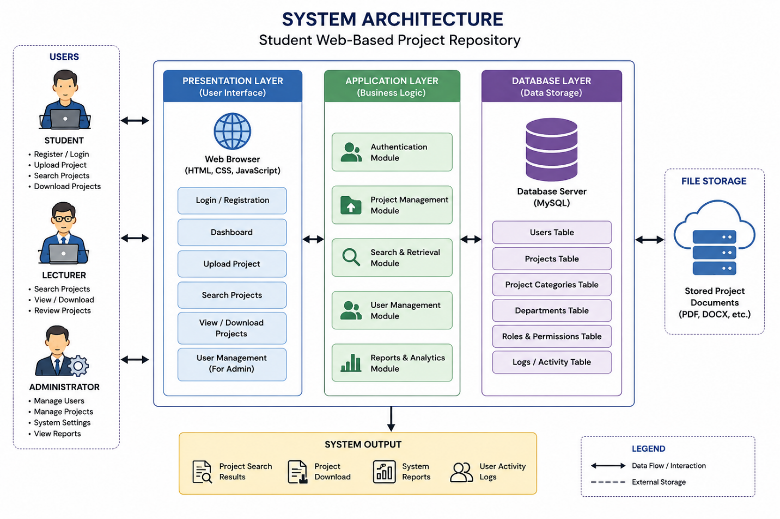
System Architecture of Student Web-Based Project Repository

3.5 Components of System Architecture
The architecture of the proposed system consists of the following major components:

User Interface Module
This component provides the graphical interface through which students, lecturers, and administrators interact with the system. It includes forms, dashboards, and search interfaces.

Authentication Module
The authentication module verifies user credentials during login and controls access based on assigned user roles.

Project Management Module
This module handles project uploads, updates, categorization, storage, and retrieval. It allows users to manage project documents effectively.

Search and Retrieval Module
The search module enables users to locate projects using keywords, project titles, departments, authors, and academic sessions.

Database Management Module
This component manages the storage and retrieval of project records, user information, and uploaded files. It ensures data consistency and integrity.

Administration Module
The administration module allows administrators to manage users, approve project submissions, monitor repository activities, and maintain system security.

3.6 Flowchart of the System
The system begins when a user accesses the repository through a web browser. The user is presented with the login page where authentication is performed. If the login credentials are valid, the user gains access to the appropriate dashboard based on their role.
Students can upload project reports, search existing projects, and view project details. Lecturers can search, review, and access uploaded projects for academic purposes. Administrators can manage users, approve uploaded projects, and maintain the repository database.
Whenever a project is uploaded, the system validates the file and stores both the project document and its associated metadata in the database. Users searching for projects submit search queries, which are processed by the search module. Matching results are retrieved from the database and displayed to the user.
The process continues until the user completes the intended operation and logs out of the system. The logout process terminates the active session and returns the user to the login page, ensuring system security and proper access control.
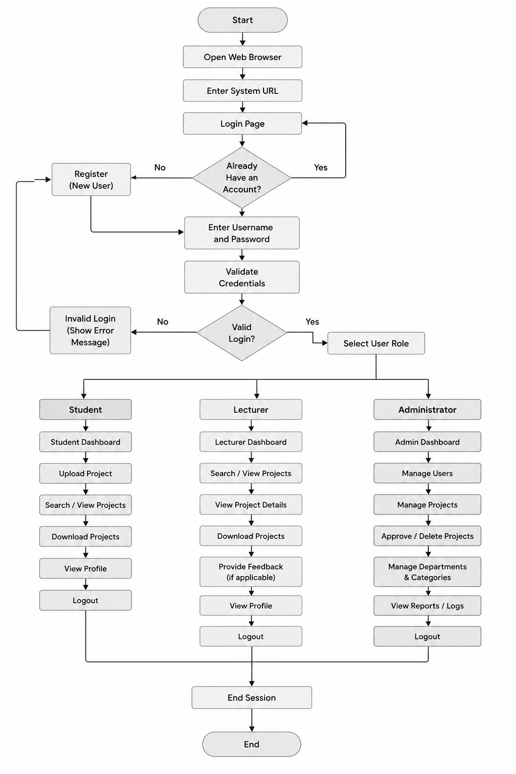
System Flowchart

